Cmod

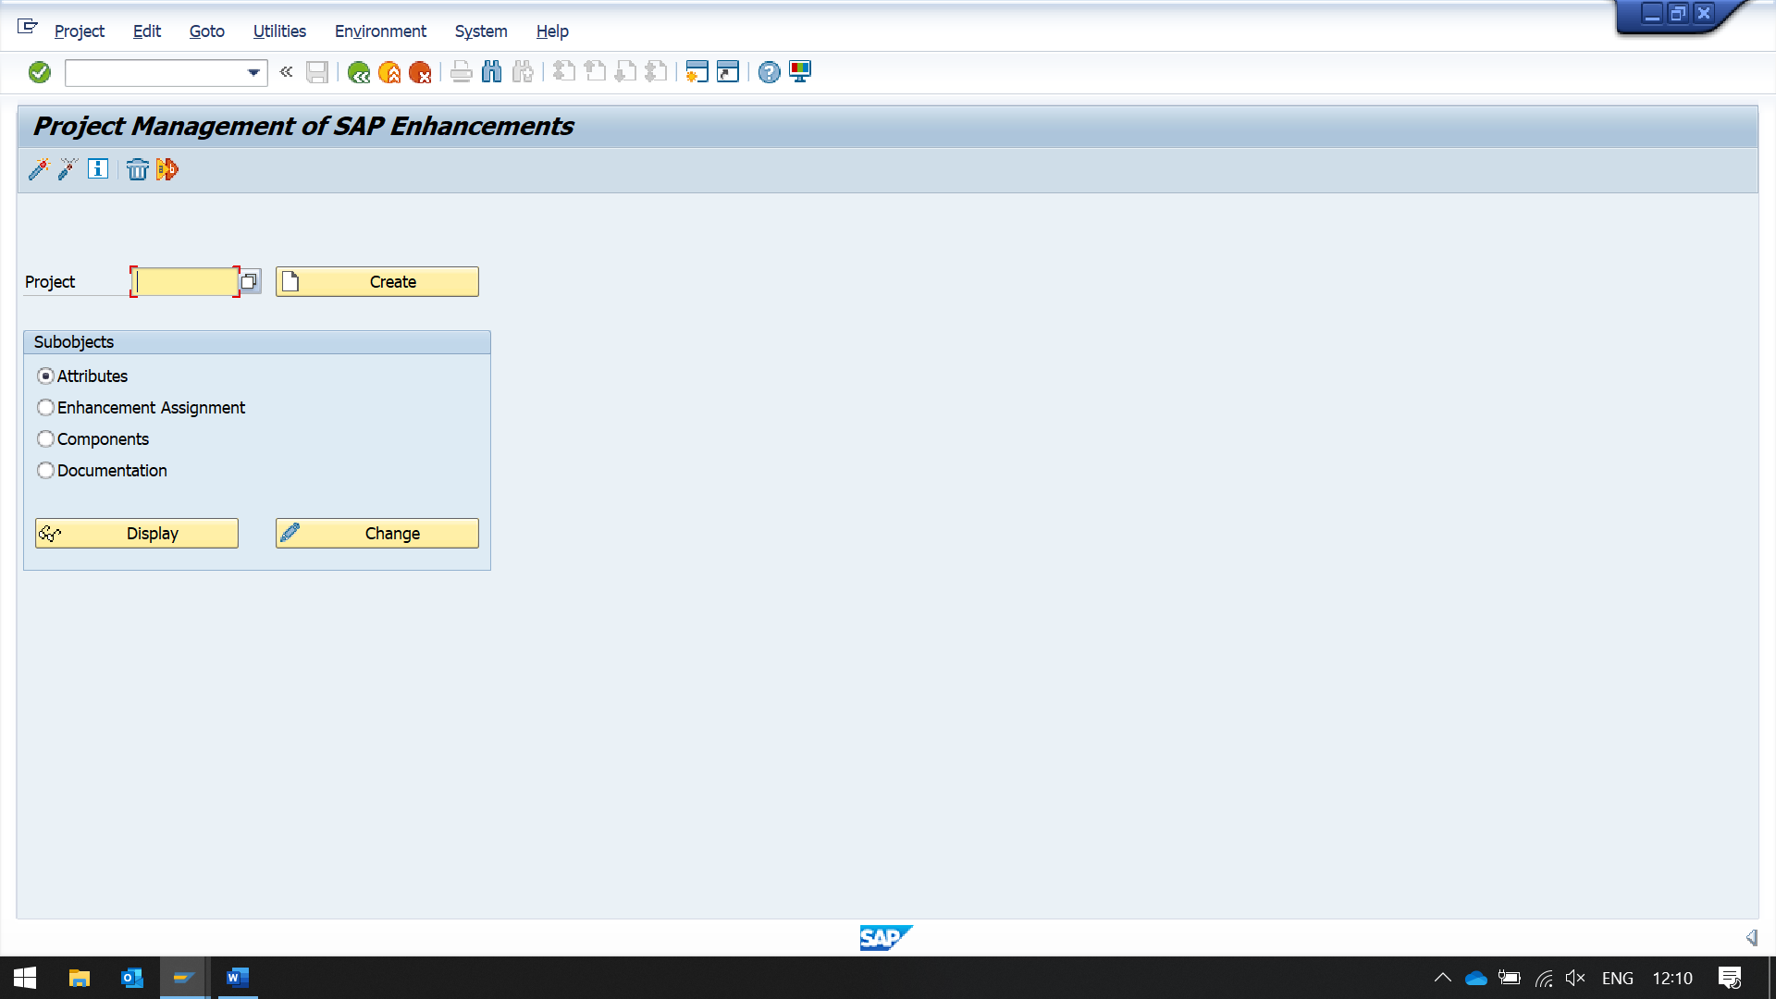 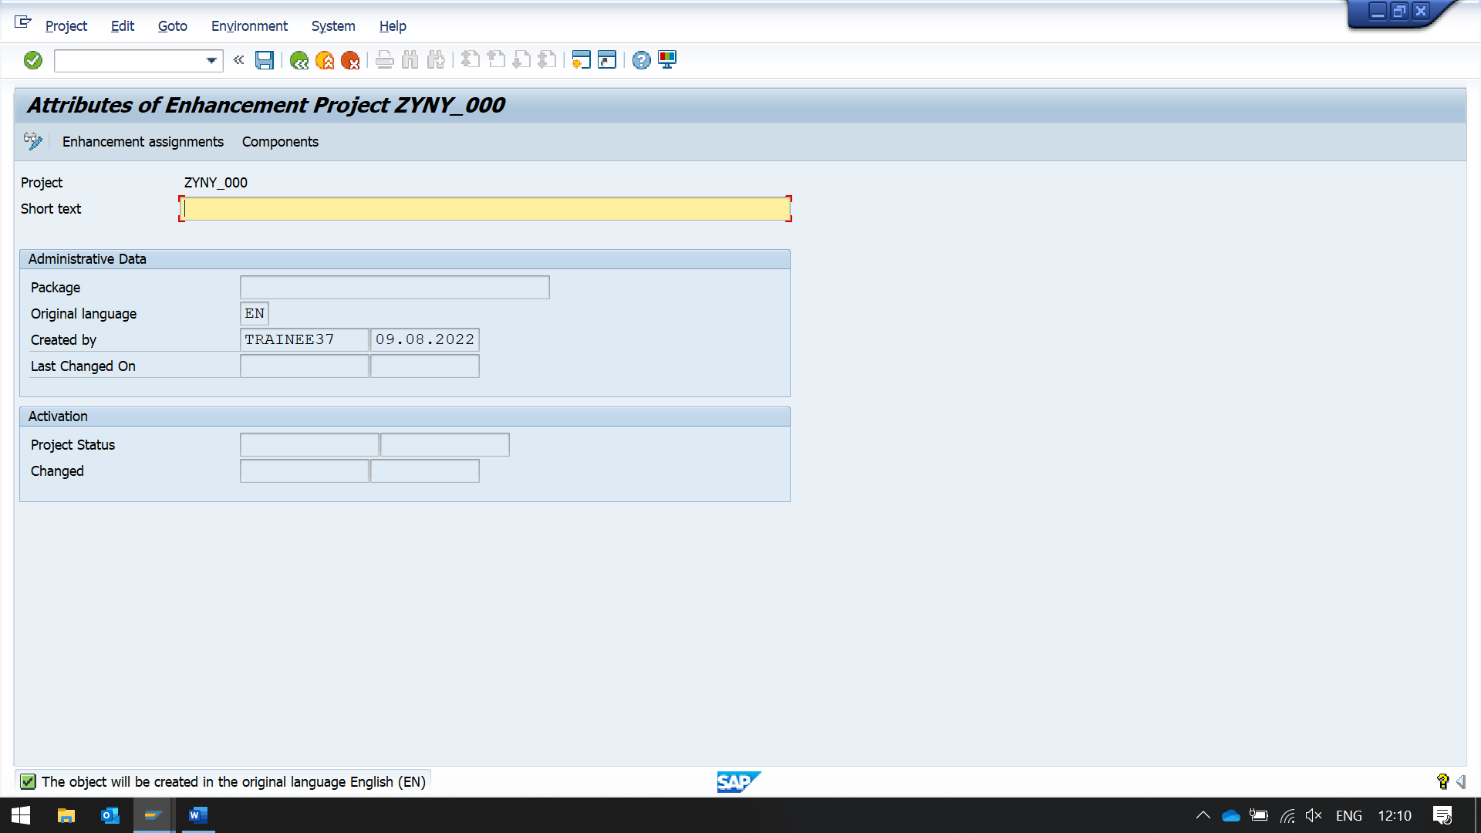

Create project

Then enter short text

Click on Enhancement assignment

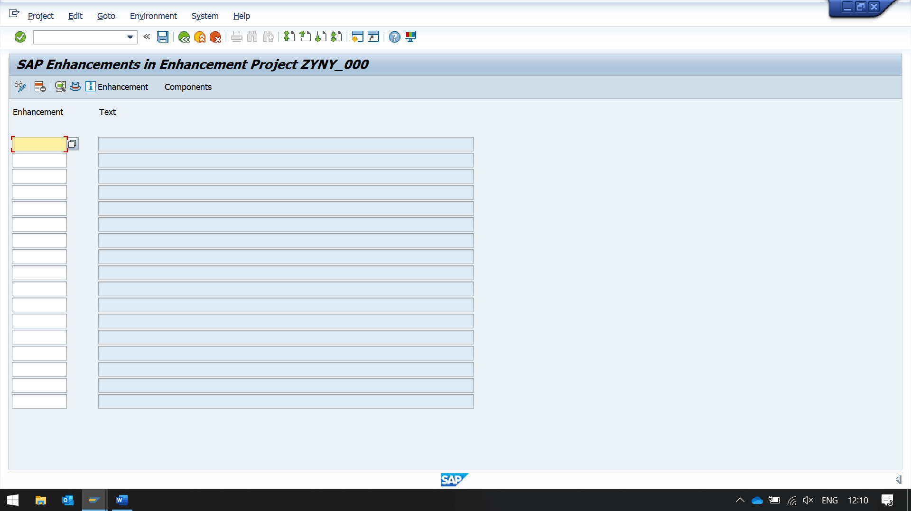

Clickon the components button above

You will get exit name

A function module will open

Double click on on a include module

Double clickon the exit name

Give your enhancement nema

Smod -> to find the existing enhancements and exits inside the enhancements we can see in this t- code.

SE24

SE1 8 – SMOD- TO SEE THE BADI DETAILS

SE19 – CMOD – TO IMPLEMENT THE BADI

HOW DO WE FIND BADI FOR A GIVEN T CODE

SE24 – CL_EXITHANDLER -> GET_CLASS _NAME_BY_INTERFACE